Lightwave Group Plan for Growth

with an application form for a group

to join the Lightwave Community



What is Lightwave?
Lightwave is a Christian community, meeting in small groups committed to shining the light of Jesus in Suffolk through acts of kindness and practical service as well as worship and witness. Lightwave groups are like “micro-churches”: They worship, study scripture, pray and live a eucharistic life - but in a whole variety of different ways, suited to the needs of their members and the context of a small group who get to know each other well. Each group discerns what God has called them to do in mission, to make disciples and and to be part of a wave of God’s love which brings light to our county.

Making a Plan for Growth for your Lightwave Group
Your Lightwave group will be discerning together how God is calling you to reach out in your community. There is a special guidance booklet to help you do this called “Creating a Plan for Growth - Lightwave Group Guide”. You can download this from www.lightwave.community/resources This will help you to listen to God, your local community and local churches and you consider your priorities. Your Lightwave group plan for growth can be an important part of a Benefice Plan for Growth.

Joining Lightwave
Filling in this form is an application to join Lightwave as a member group.

Benefits for include:
- Opportunities to meet and share with others in a network of groups who are reaching out in similar ways
- Access to quality training
- Matching with a coach/mentor to help you develop your group’s mission
- Support for safeguarding which has the small group context and fresh expressions of Church especially in mind
- Small Mission Grants available to member groups for specific mission activity (up to £500)
- The opportunity to apply for a group member to become a Rural Outreach Pioneer, paid for one day a week to engage in a clearly identified rural outreach and evangelism activity
- The ability to get tax back on donated funds specifically for the use of your group or fresh expression of church – through the Lightwave Community CIO (a registered charity) if you are not affiliated to your local PCC
- Support in developing financial sustainability and good stewardship in your group/fresh expression of church.

Applications are considered by the Lightwave Community Council which meets regularly. Groups may be composed of people from any Christian denomination. The Council will talk with the CofE incumbent (and other ministers where appropriate) of the areas in which your group has its life before enrolling the group in Lightwave. You are asked to state that you follow the Christian faith as understood in the creeds and are intentionally seeking for the group to be shaped by the following five practices (though it is appreciated that your group may use different terms to describe these and that is fine). You will need to have a plan for growth which includes helping people to become disciples.

Note: Groups may elect to come under the governance of their local PCC if they operate in a single parish, or under the governance of the Lightwave Community which is covered by a Diocese-wide Bishops Mission Order (BMO). If the former, you will also need to talk to your local incumbent to ensure you are covered by their processes, e.g. safeguarding and insurance, gift aid.


Group Practices
- All Involved – Everyone is included and valued. Everyone is involved in collaborative ministry
- Becoming Disciples – A deliberate commitment to grow in faith and help each other to become more like Jesus
- Creating Community – Community involves doing life together (which normally but not always involves meeting weeky) “being real” with each other -to be honest about the things we go through ourselves and to respond in a loving way to each other. Caring for each other enables us to care for our wider community too. Small missional groups are encouraged to support one or more of the parish churches in their benefices and, where appropriate, churches of other denominations as part of their commitment to Christian community
- Doing Evangelism – being, doing and telling good news including giving other people the opportunity to learn about Jesus
- Encountering God – Reverence and Awe. Meeting with God – it is God who helps us and changes us.

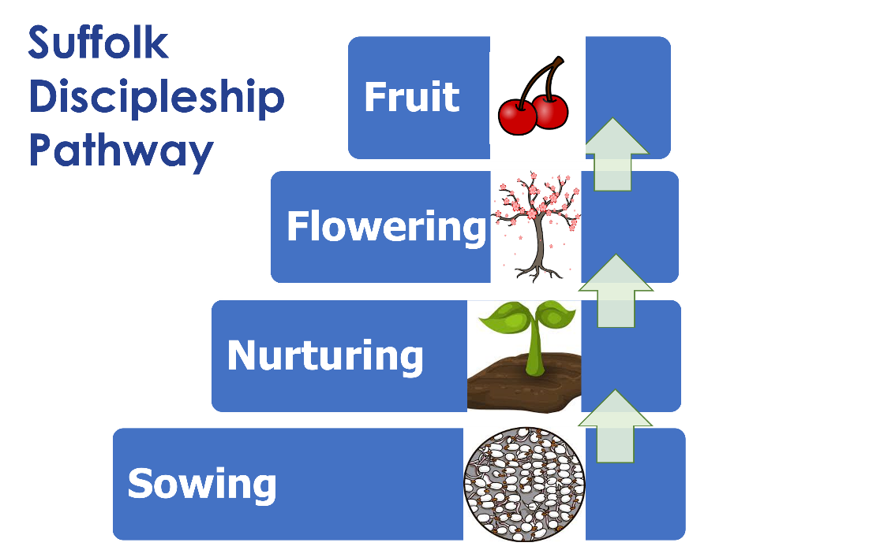

The Suffolk Discipleship Pathway is a way of describing the steps that most people take on their way to discovering and growing in faith.
It helps churches and small groups to think about how they can provide stepping stones to faith for the people they are in contact with.

A brief explanation of each step step in the pathway is given in this form – and more ideas can be found in the booklet called “Creating a Plan for Growth - Lightwave Group Guide”. There is also a film explaining the pathway. You can find these at www.lightwave.community/plan-for-growth


GROUP APPLICATION & PLAN FOR GROWTH (EXAMPLE GIVEN OVERLEAF)
- Name of Lightwave Group:
- Geographical area or network in which the Group has its life:

- Tell about your regular Lightwave Group meetings. (This will usually be the team leading the fresh expression of Church as you pray and study the scriptures and plan mission together. (Use the prompts in blue if helpful) | All Involved – How you make sure everyone has a part to play.  Becoming Disciples – What you do together to grow in faith and help each other to become more like Jesus – bible study, worship etc  Creating Community – How you care for each other and those around you.  Doing Evangelism – How you share the good news of Jesus  Encountering God – How you meetiwith God and the difference it makes
- Tell us one priority for developing the life of your group this year. (eg. Leadership training, focus on prayer)

- Tell us about the particular mission focus of your Lightwave group. For example, you might feel called to a particular age group like parent and toddler outreach or people with particular needs like a group involved in a food pantry.

- Tell us how you will seek for the Lightwave Group to help new people to come to faith and grow as disciples? (Use the prompts in blue if helpful) | Sowing - What your group is doing to make contact, or meeting a need – This is loving unconditionally and as you get to know people you may notice that some are open to an invitation to nurture their faith.  Nurturing – These are opportunities for people’s faith to grow – with digestible spiritual content at different levels to meet their interest – eg a discussion in the pub on spiritual matters, Messy church, a carol-service.  Flowering – This is an opportunity you make for someone who wants to explore making a faith commitment such as Alpha or Confirmation Preparation.  Fruit – These are opportunities to grow in depth of faith and to engage in Christian service. The regular bible study and mission activity of your group will probably be the place where this can happen.

LOCAL BENEFICE AND OTHER CHURCHES
Name and contact details of local Anglican incumbent:
Have you already consulted them about this group and joining Lightwave? | YES/NO
Name of any other church involved and contact details
Have you consulted them about this group and joining Lightwave? | YES/NO
Do you want to come under the governance of the BMO or your local PCC? | BMO/PCC

LIGHTWAVE GROUP LEADER 1
Title: | Surname:
First Name (s):
Full address:

Post Code:
*Phone number: | *Email address:
Basic Awareness (Previously C0) YES/NO | Date completed/scheduled:
Foundation (Previously C1) YES/NO | Date completed/scheduled:
Leadership (Previously C2 and C3) YES/NO | Date completed/scheduled:
Have you had a DBS check? YES/NO | Date completed/scheduled:
Signed: | Date:

LIGHTWAVE GROUP LEADER 2
Title: | Surname:
First Name (s):
Full address:

Post Code:
*Phone number: | *Email address:
Basic Awareness (Previously C0) YES/NO | Date completed/scheduled:
Foundation (Previously C1) YES/NO | Date completed/scheduled:
Leadership (Previously C2 and C3) YES/NO | Date completed/scheduled:
Have you had a DBS check? YES/NO | Date completed/scheduled:
Signed: | Date:

LIGHTWAVE GROUP SAFEGUARDING LEAD
The care and protection of children, young people and vulnerable adults involved in Lightwave activities is the responsibility of the whole church and a vital priority for Lightwave.

The Lightwave Safeguarding Team have asked that the person responsible for Safeguarding for your group (either a leader or another person such as a Parish Safeguarding Officer or someone from a local Lightwave Rural Hub) is clearly stated and signs that they are accepting that responsibility as part of this application. The person must have an up to date DBS check (which we can facilitate if necessary) and must have completed all training up to Leadership Level.

If this person is also a leader of the group then just record their name here and record the other information above. Otherwise please complete in full.

Title: | Surname:
First Name (s):
Full address:

Post Code:
*Phone number: | *Email address:
SAFEGUARDING TRAINING
Basic Awareness (Previously C0) YES/NO | Date completed/scheduled:
Foundation (Previously C1) YES/NO | Date completed/scheduled:
Leadership (Previously C2 and C3) YES/NO | Date completed/scheduled:
Have you had a DBS check? YES/NO | Date completed/scheduled:
I confirm that I am the lead person responsible for safeguarding for this Lightwave Group
Signed: | Date:

SAFEGUARDING TRAINING NOTE: All Lightwave Group leaders are required to have a current Diocesan DBS check (which we can facilitate if necessary), and to have completed Basic and Foundation Training which can be completed online. At least one of the leaders OR a separate Safeguarding officer (see below) must also have completed Leadership training. Anyone in the group involved in leading activities with children or vulnerable adults must also have completed Safeguarding Leadership Training

Please record current level of Diocesan safeguarding training received & date training was undertaken or date scheduled to be completed. To book training go to: https://www.cofesuffolk.org/safeguarding-training/

Please be aware that applications cannot be accepted until the safeguarding sections of the form are completed.

MEMBERS
Please ask each member to add their name to the list below and sign. Continue on a separate sheet of paper if necessary.

Alternatively members can email andrew.gosden@cofesuffolk.org with this information confirming they are members of the group.

By entering and signing against their name below each member is declaring that they are eligible for membership and are applying to be members of the Lightwave Community.
Full name | Have you been baptised (Y/N)? | email address* | Signature (or ask the member to send an email confirming consent to andrew.gosden@cofesuffolk.org)

Return all sheets to Andrew Gosden by emailing the document or a scanned/photo version to andrew.gosden@cofesuffolk.org.

If you have any problems completing this form, please contact Andrew Gosden by email on andrew.gosden@cofesuffolk.org or phone on 07711 753312, who will be pleased to help you.

The small print…
Anyone can be a member of the Lightwave Community if they subscribe to the ABCDE Christian values, but to be able to vote for members of the Lightwave Community Council or at future Annual Meetings or become a member of the Board you must fulfil all the following conditions:
- Be baptised AND a member of a church as outlined in (ii) below, and aged 16 or over.
- Be either a member of the Church of England OR a Church in communion with the Church of England, OR a member of a Church not in communion with the Church of England which subscribes to the doctrine of the Holy Trinity.
- Have habitually attended at missional group meetings of the Lightwave Community during a period of six months prior to enrolment.

*Use of email addresses and other personal data:

- You do not have to provide an email address on this Form. If you do provide one, the Lightwave Community Council and the electoral roll officer are entitled to use that email address to communicate with you in connection with the maintenance or revision of the Roll or the preparation of a new Roll or with elections to or membership of the Council.
- The Church Representation Rules impose certain requirements for your name and address to be given to a third party, such as the diocesan electoral registration officer, in connection with elections to or membership of a deanery synod, diocesan synod or the House of Laity of the General Synod. If you provide an email address on this Form, it will be given to the third party along with your postal address.
- A third party to whom your name and address have been given under the Church Representation Rules is in certain cases required by the Rules to pass them on to another person, such as the presiding officer in a synodical election. If you provide an email address on this Form, that email address will be given to the other person along with your postal address.
- Any person to whom your email address or other personal data is given under the Church Representation Rules is required by those Rules to hold the data securely. Furthermore, if you do provide an email address on this Form, that does not give anybody the right to use it for any purpose other than those permitted by the Rules; so it cannot, for example, be used for social matters or fund-raising.
- The roll is published after each annual revision and after the preparation of a new roll. The published roll will include your name (as well as the name of every other person on the roll) but none of your other personal data (as defined by the Data Protection Act 2018) will be made public as a result of your inclusion on the roll.

